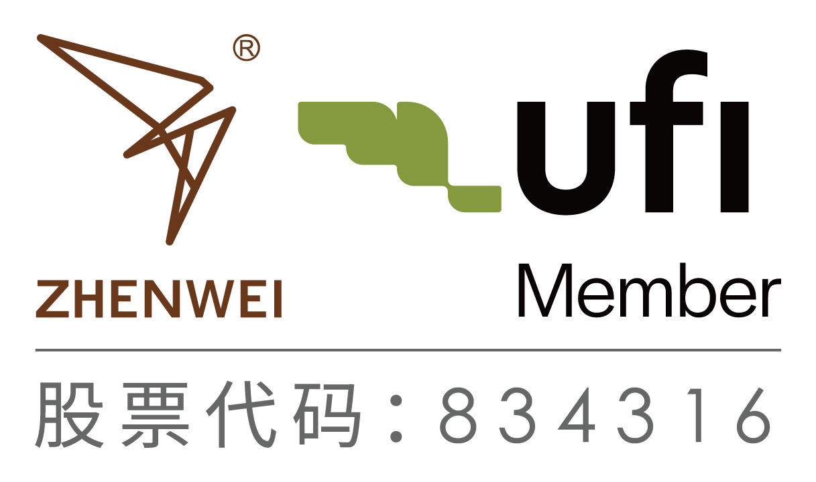**INVITATION**

**To: From:**

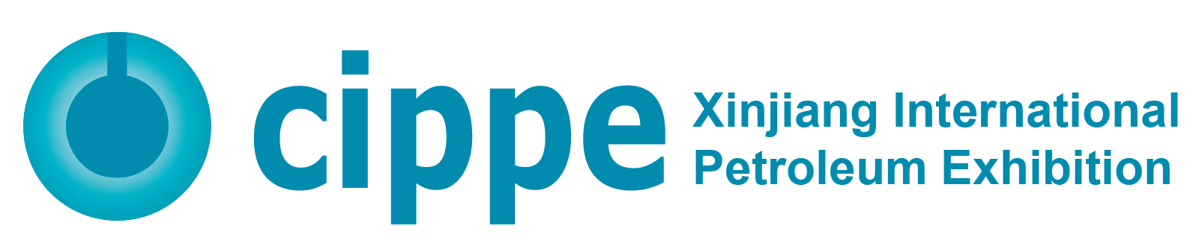

**2026 Xinjiang International Petroleum & Petrochemical Technology and Equipment Exhibition**

**July 15-17, 2026**

**Xinjiang International Convention and Exhibition Center**

**Organizers**

Zhenwei International Exhibition Group

Beijing Zhenwei Exhibition Co., Ltd.

**Supporters**

China Petroleum and Chemical Industry Federation

China Petroleum & Petrochemical Equipment Industry Association

Explosion-Proof Electrical Apparatus Branch of China Electrical Equipment Industry Association



**About the Event**

Xinjiang lies in hinterland of the Eurasian continent and adjourns countries in central Asia, south and west Asia, connects two large markets with 1.3 billion people, and functions as a key gate and base for China’s opening up. In view of the guidance of CPC, Xinjiang has gradually become an important base for large-scale oil and gas production, oil refining and chemical development, oil reserves and engineering and technical services in China.

Oil & gas industry has not only been a pillar industry in Xinjiang, but arguably it is unparalleled in national energy security and supporting the BRI constructions. Since the three central symposiums on work related to Xinjiang held in Beijing, our central government, the autonomous region and CNPC have collectively issued a series of policies and measures to promote leapfrog development and long-term stability in Xinjiang, providing a strong impetus and a favorable development environment for Xinjiang's steady development. With progressive work in aid into Xinjiang and the BRI, cippe Xinjiang embraces unprecedented business opportunities and extensive market potentials.

2026 Xinjiang International Petroleum & Petrochemical Technology and Equipment Exhibition (cippe Xinjiang) will be held on July 15-17, 2026 at Xinjiang International Convention and Exhibition Center. With an gross exhibition space of 40,000sqm, it is expected to welcome 500+ exhibitors and 50,000+ person-time visitors from home and abroad.

**Concurrent Events to Promote In-Depth Exchanges on Cutting-Edge Technologies**

Concurrently, with supports from the industry associations, research institutes, experts and enterprises, cippe Xinjiang will hold symposiums covering the whole chain through the upstream to downstream, delivering a high-quality summit of the industry in Northwest China.

**Matchmaking Meeting to Effectively Connect Demand and Supply**

cippe Business Matchmaking Meeting will be a brand event of cippe Xinjiang, aimed to provide a highly-effective, accurate and reliable platform connecting demands and supply. The organizing committee will invite potential purchasers, and arrange one-on-one communications for buyers and exhibitors based on buyers’ sourcing needs.

In 2025, 20+ energy and chemical industry parks, such as Xinjiang Zhundong Economic Development Zone, Kuitun-Dushanzi Economic and Technological Development Zone, Karamay Petrochemical Park, Baicheng Heavy Chemical Industrial Park, Toksun Energy & Heavy Chemical Industry Park, Xinjiang Shanshan Chemical Park, Fukang Heavy Chemical Industrial Park, Kuqa Petrochemical Industrial Park, Ganquanbao Economic Development Zone, Wusu Chemical Park, Midong Chemical Park, Luntai Chemical Park, Yidong Industrial Park in Ili Kazak autonomous prefecture, etc.; 500+ energy and heavy chemical enterprises covering petroleum and chemical, natural gas, oil and gas pipelines, coal chemical, salt chemical, chlor alkali, fertilizer and related industries, including Xinjiang Oilfield, Tarim Oilfield, Tuha Oilfield, CNPC Xibu Drilling Engineering Company Limited, PetroChina Urumqi PetroChemical Company, Dushanzi Petrochemical Company, Karamay Petrochemical Company, Sinopec Northwest Oilfield, PipeChina Western Pipeline Company, SPIC Xinjiang Energy and Chemical Co., Ltd., Huaneng Xinjiang Energy Co., Ltd., Huadian Xinjiang Power Co., Ltd., Datang Xinjiang Power Generation Co., Ltd., State Grid Xinjiang Electric Power Co., Ltd., Yankuang Xinjiang Energy & Chemical Co., Ltd., Zhongtai Chemical, China Energy Group Xinjiang Energy Co., Ltd., Xinjiang Yihua Chemical, Guanghui Energy, SDIC Xinjiang Luobupo Potash Co.,Ltd., KINGHO, Xinjiang Yitai Energy, SDIC Hami Energy Company, Xinjiang Tianye (Group) Co., Ltd., XINJIANG JOINWORLD, Lu'an Xinjiang Coal Chemical (Group) Co., Ltd., Henan Energy and Chemical Group Xinjiang Investment Holding Co.,Ltd., SNXON, etc.; 100+ petroleum and chemical design institutes and engineering contractors, such as CNPC China Petroleum Engineering Co., Ltd., China Petroleum Engineering & Construction Corporation, China Petroleum Pipeline Engineering Co., Ltd., PetroChina West Pipeline Co., Sinopec Engineering Incorporation, Sinopec Engineering (Group) Co., Ltd., China Tianchen Engineering Corporation, Huatai Engineering Corporation, Wuhuan Engineering Co., Ltd., Sinopec Nanjing Engineering Co., Ltd., China Chengda Engineering Co., Ltd., China Huanqiu Contracting & Engineering Corporation and others will be invited to come for business cooperation.

***Exhibitions Linkage to Ensure the Quality of Professional Visitors***

With more than two decades’ development, the organizer, Zhenwei International Exhibition Group, has been a most specialized exhibition company with rich and profound resources in the industry. Both of its cippe Beijing, cippe Shanghai and cippe Chengdu are leading brand exhibitions. As a significant trading platform, with favorable resources, this exhibition will greatly promote the industry development.

***Quality Medias Support Brand Communications***

cippe Xinjiang will cooperate with domestic and abroad media partners to promote brand communications, such as Xinhua News, People's Daily, CCTV, China Daily, CNPC Daily, Sinopec Daily, Petroleum Business News, Upstream, Gulf Oilfield Directory, China Securities Journal, Shanghai Securities News, China Business News, Wall Street Journal, XINHUANET, Sina, Sohu, PeopleNet, XJTV, UTV, Media Network Bing Tuan, Xinjiang Daily, Urumqi Evening News, Bing Tuan Daily, etc.

***Exhibition Schedule***

Registration & Setting up: July 13-14, 2026

Exhibition Opening: July 15-17, 2026

Closing & Dismantling: Begin at 14:00p.m., July 17, 2026

***Exhibit Profile***

• Oil & gas exploration, exploit, and production equipment

• Geophysical exploration, well logging and drilling technology and equipment

• Well completion technology and equipment

• Marine engineering technology and equipment

• Natural gas technology and equipment

• Automation technology equipment, instruments and meters

• Oil and gas field surface engineering technology and equipment

• Petroleum & petrochemical equipment and manufacturing

• Industrial explosion-proof products

• Oil and gas pipeline engineering

• Underground engineering and trenchless technology and equipment

• Power systems, power generation and supply

• Oil and Gas Storage & Transportation

• Oilfield Special Vehicle

• Electrical & electronic equipment, cable and electric wire

• Oil refining technological process and equipment

• Petrochemical process and technology

• Examination & repair, maintenance, and management

• Fluid control equipment- Compressor, Pump, Blower and Valve

• Pressure Vessels

• Oil and lubricating oil technology and equipment

• Petrochemical products and advanced material

• Refueling station equipment

• Environmental protection and energy conservation

• Fire and alarm equipment, articles for industrial safety and labor protection

• Anti-corrosion technology and material, industrial rinsing

• Packing, sealing, gasket, fastener, bearing

• Digital solutions for oil and gas industry

• Communications and information technology

• Hydrogen technology and equipment

• Certification, consulting services

• Scientific research and laboratory in petroleum & petrochemical industry

• Tools & Spare Parts

***Exhibiting Costs (Not Including VAT)***

|  |  |
| --- | --- |
| **Exhibition Space** | **Shell Scheme Booth:**  Price: CNY 19,800/9SQM; Regular Size : 3m×3m.  This option includes back & inside walls, carpet, lintel board, one consulting table, two chairs, two lights and one power socket (220V, 5A).  Please specify in advance for special electricity use, and will be charged separately.  An 20% additional fee will be charged for 2-side opening stands. |
| **Raw Space:**  Price: CNY 1,980/SQM (Minimum 36sqm).  Empty exhibition space for exhibitor to customize booth design and construction. The exhibitors shall not choose a contractor that is not designated by the organizer. |
| **Additional Exhibitor Service** | **Additional Exhibitor Service**  Price:CNY 2,200/person (Includes lunches, beverages, manuals, gifts, one-day tour, etc.) |
| **Catalogue Ad.** | **Front Cover**: CNY 25,000 **Inside Back Cover**: CNY 15,000 **Back Cover**: CNY 20,000 **Head Page**: CNY 18,000 **Inside Front Cover**: CNY 15,000 **Colored Inside Page**: CNY 8,000  **Size: 130mm (width) × 210mm (height)** |
| **Technical Seminar** | A series of technical seminars will be held during the exhibition so as to maximally meet participants’ requirements for technical communication and products launch as well.  **Technical Seminar** (Conference Room)  Price: CNY15,000/Session  Including venue, audio equipment, projector, on-site sign, water, etc. |

More Sponsorship Opportunities, please contact cippe Xinjiang Organizing Committee. And the Exhibitor Manual will be uploaded to the exhibition website in June 2026. Please download by yourself.

****Organizer: Zhenwei International Exhibition Group Beijing Zhenwei Exhibition Co., Ltd.

Add: Zhenwei Exhibition Building, Building III13, International Enterprise Avenue, Yard 1, Jinghai 5th Road, Tongzhou District, Beijing

Tel: Fax: 8610-5617 6998

Web: E-mail: [@zhenweiexpo.com](mailto:tq@zhenweiexpo.com)

**Application Form**

**2026 Xinjiang International Petroleum & Petrochemical Technology and Equipment Exhibition**

**July 15-17, 2026 Xinjiang International Convention and Exhibition Center**

Please fill out the form below and then send it back to the organizer via fax or email.

Company Name:

Address: Country: Postal/Zip code:

Contact (Mr. / Ms.): Position:

Mobile: TEL: FAX:

Website: E-mail:

Main products/exhibits (English):

**Exhibition Space**

□ Shell Scheme: SQM (CNY19, 800 / 9sqm)

Preferred Booth Number: Fee:

* Raw space: SQM (CNY1, 980/sqm minimum 36sqm)

Preferred Booth Number: Fee:

**Sponsorship & Advertisement**

|  |
| --- |
| * **Exhibition Catalogue Ad.**   □ Front Cover CNY25,000 □ Inside Front Cover CNY15,000 □ Head Page CNY18,000  □ Back Cover CNY20,000 □ Inside Back Cover CNY15,000 □ Colored Inside Page CNY8,000   * **Technical Seminar**: CNY15,000/Session Session(s) * **Additional Exhibitor Service:** CNY 2,200/person Person(s) * **Media Promotion:**   □ Pre-show: CNY 2,000/time □ Post-show: CNY 2,000/time □ During the show: CNY 7,000/time   * **Photography Service:** CNY6,000/day * **Live Streaming**   □ cippe Discoveries Live-stream, CNY5,000/session □ Customized Live-stream, CNY50,000/day |

**Total fee:**   **Payment Date:**

**The amount excluding tax is:**   **And the tax is (with a tax rate of 6%）:**

**Special Attentions:**

1. Please remit the total payment to the account appointed by the organizer within 10 business days upon receipt of the confirmation letter; 2. Booking received without this deposit will not be confirmed; 3. Payment cannot be refunded if exhibitors failed to exhibit for their own reasons; 4. The exhibits should meet the exhibition scope and theme, and should not infringe intellectual property rights, otherwise the exhibitors should bear all legal responsibility; 5. Exhibitors shall not choose a contractor that is not designated by the organizer.

|  |  |
| --- | --- |
| **Beijing Zhenwei Exhibition Co., Ltd.**  **Tel:** +86  **Mobile:** +86  **Email:**  **Contact:** | **Company Name:**    **Signature & Stamp:** |